CELLNO

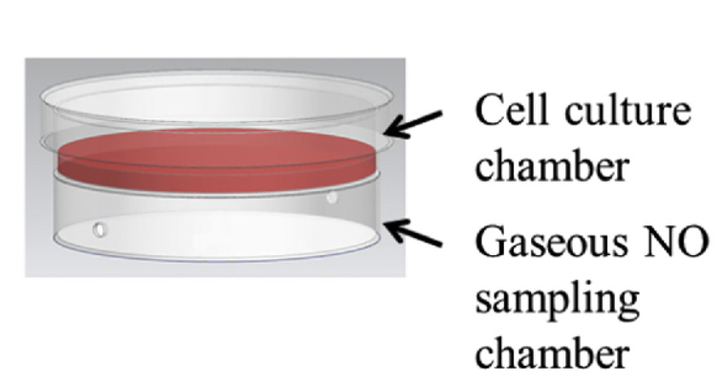
CELLNO is a patented sampling device (Figure 1) developed by Dr. Megan Frost of Michigan Technological University for real time measurement of nitric oxide from cell culture. This device offers the researcher the ability to culture live cells in a sterile chamber with the ability to monitor real time NO production from the cells. Nitrogen or ambient air is used as a carrier gas to sweep the NO produced by the cells into to the Zysense NOA 280i Nitric Oxide Analyzer as shown in Figure 2.

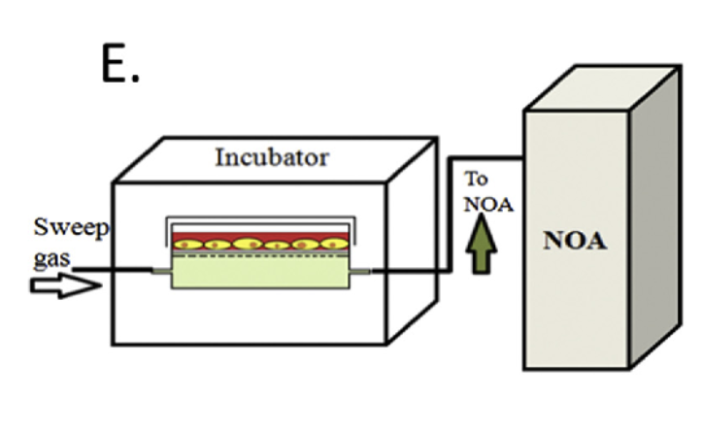
Figure 1
Figure 2
It has been clearly shown that measurement techniques like Griess Assay, Electrochemical methods are not reliable (Anal. Chem., 2013, 85 (3), pp 1957–1963) for in vitro NO measurements and chemiluminescence is suited better for reliable measurement for actual NO determination. The results of this study highlight the importance of measurement strategy for accurate NO analysis and reporting NO-based biological activity.

In order to achieve reliable, repeatable, real time data, a highly reliable, sterile, cell culture chamber is needed to quantitatively measure NO production. CELLNO was developed to address this critical need to obtain real time, NO data with temporal and patial control that is impractical in biologically relevant media. CELLNO has been optimized to eliminate foaming with the use of a sweep gas and precisely record NO released from the cells.

Zysense NOA 280i (Chemiluminescence Analyzer) is widely used to measure the reaction kinetics and for the accurate measurement of Nitric Oxide.

